A Novel Idea
- August - September 2017 by Margie Jacinto
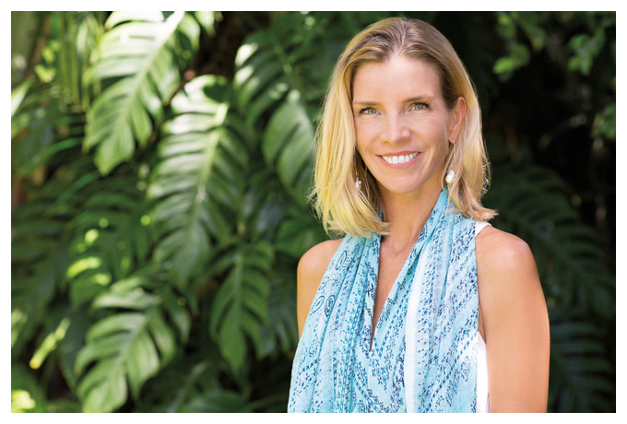
Author Malia Mattoch McManus’ new book, Dragonfruit, pays a visit to Hawai‘i’s past—as well as a bit of her own.
When Malia Mattoch Mcmanus came out with home design tome the Hawaiian House Now almost a decade ago, it was safe to assume her second book would pertain to a topic along similar lines. So, a historical fiction novel set in Hawai‘i’s most tumultuous period is perhaps a genre even McManus herself wasn’t expecting to pen. But inspiration strikes at the most unlikely places, and for the Kailua-born writer and reporter, it struck on an almost-secluded beach on Moloka‘i years ago. Now, with her first published novel already garnering rave reviews, McManus gives us the story behind her recently released book, Dragonfruit.
What prompted you to write Dragonfruit?
Many years ago, I was counting turtles overnight for the Nature Conservancy on Moloka‘i. I heard a woman’s laugh coming from behind an abandoned ruin on the beach. We looked for the woman but never found her, though her laugh went on throughout the night. This was the first and, I think, last time I’ve ever had this feeling. The friend I was counting the turtles with, who is part Hawaiian, never could hear the woman as I did … “Because that’s the crazy haole ghost,” [my friend, Pi‘ikea’s] grandfather told me, naming an old Hawai‘i missionary family as the source of the ghost. I have no idea if Pi‘i’s grandfather was just pulling my leg, but it planted an idea in my head—what would bring such a woman to a place like that, and what would drive her to haunt it?
How does the novel come into play?
Dragonfruit’s main character, Eliza Dawson, does not fit the profile of that ghost, but the genesis of her heartbreak, adventure and redemption came from that night. From there, years passed as I worked as a reporter and collected little bits and pieces during stories about O‘ahu cemetery or ‘Iolani Palace. Each Palace guide told a slightly different version of events, and each detail is still lodged in my mind …
Are there any other personal aspects woven into the story?
Another dear Hawai‘i friend, Heather Ho, had passed away in 9/11. I wanted to add something about friendship and loss, but love too, and that’s where the component of the friendship with Ka‘iulani and the storyline of the Chinese family came in. I wanted to honor Heather’s roots in a way that was totally fictional to her actual life, but allowed me to spend time reading about that community’s history in Hawai‘i, which is a fascinating one.
Final details came in as I took my young sons to Bishop Museum once a week to walk through the Hawaiian Hall. The collection provided ideas for the twists and turns and other characters’ plot lines. The feather cloaks, old photographs, priceless pieces—many found their way into this book that took me so long to write but I hope honors the Hawai‘i I find so rich and unique. This story couldn’t take place anywhere else in the world than here …

